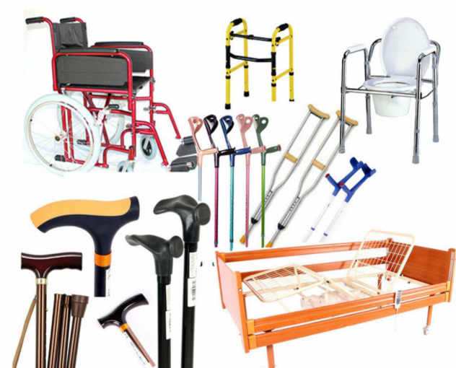
APPLICATION
for financing of the humanitarian project
of the institution "Kirovsky district Center for Social services of the population"

1. | Name of the project | Rehabilitation art therapy
2. | Name of the organization | institution "Kirovsky district center for social services of the population"
3. | The physical and legal address of the organization, phone, fax,  e-mail | Mogilev region, Kirovsk, Kirova str., 63,  8(02237)79533, kirovsk.c@mintrud.by
4. | Information about the organization | In 2000, the Kirovsky District Center for Social Services of the Population was established to improve work with the population at their place of residence.  The main activities of the organization:  -identification and differentiated (by category) accounting of citizens in difficult life situations, determination of the forms of social services they need, types of social services, etc.
5. | Project Manager  The head of the organization | Director - Alesya Mikhailovna Sittseva, 8(02237)77302
6. | Project Manager | Pashkevich Elena Petrovna, Head of the department of round-the-clock stay for elderly and disabled citizens, 8(02237)74337 kirovsk.c@mintrud.by
7. | Previous assistance received from other foreign sources | -
8. | Required amount | 40025 US dollars
9. | Co-financing | -
10. | Project duration | 12 months
11. | The purpose of the project | Providing disabled and elderly citizens with round-the-clock departments for elderly and disabled citizens with the necessary equipment to improve living conditions, assistance in restoring lost abilities
12. | Project objectives | Acquisition, restoration and development of impaired body functions available to the elderly and people with disabilities, as well as the prevention of diseases in older people, increasing the availability of physical education and wellness services for the disabled and elderly citizens; formation of a positive attitude towards their health among disabled and elderly citizens; popularization of an active and healthy lifestyle
13. | A detailed description of the activities within the project in accordance with the tasks set | Identification of the target group and involvement of disabled and elderly people to participate in the project; conducting informational conversations with elderly and disabled people on healthy lifestyles, self-preservation behavior, physical activity, healthy eating, positive attitude to their health
14. | Justification of the project | The social significance of this project lies in the elimination of numerous physical, psychological, social and other barriers that exist in modern society and hinder the full-fledged life of the elderly and people with disabilities.  The project provides for the possibility of rehabilitation of the elderly and people with disabilities at their place of residence.  The project will be implemented in stages and will begin with a diagnosis, the main purpose of which is to determine the knowledge, skills and abilities of an elderly person and people with disabilities for the subsequent selection of an individual complex of habilitation and rehabilitation measures (individual development trajectory).
15. | Activities after the end of the project | Raising awareness of disabled people and elderly citizens on issues of self-preservation behavior, physical activity, and healthy eating;  formation of a positive attitude towards their health among the disabled and elderly citizens;  attracting at least 10 elderly and disabled citizens living in the OKP to a healthy and active lifestyle during the first year of the project.
16. | Project budget | 40025 US dollars

