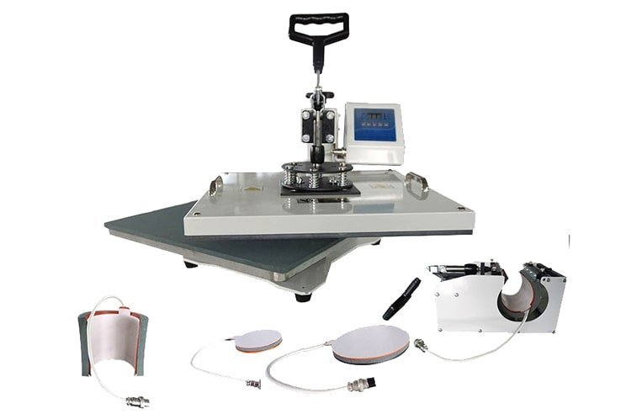
REQUEST
to finance a humanitarian project
Institutions "Kirovsky District Center for Social Services"

1. | Name of the project | Opportunity studio "Print"
2. | Name of company | institution "Kirovsky district center of social services"
3. | The physical and legal address of the organization, phone, fax, e-mail | Mogilev region, the city of Kirovsk, Kirov street, 63, 80223779533, RCSON06@mail.ru
4. | Organization Information | In 2000, the institution “Kirovsky District Center for Social Services for the Population” was established to improve community outreach.  The main activities of the organization:  - identification and differentiated (by category) registration of citizens in difficult situations, determination of the forms of social services they need, types of social services, etc.  The institution employs 92 employees (staffing 96 people), including heads of structural divisions 10 people, specialists 23, workers 15, social workers 44
5. | Head of the organization | Director of the center Merzhiy Olga Nikolaevna, 80223777302
6. | Project manager | Natalya Finevich, Head of the Day Care Unit for Disabled and Senior Citizens, 80223779533; +375291703685, kirovsk.c@mintrud.by
7. | Previous assistance received from other foreign sources | -
8. | Amount Required | 1000USD
9. | Co-financing | 500USD
10. | Project term | 1 year
11. | Objective of the project | Opening of an inclusive studio "Print", aimed at creating products with designer drawings on clothing and tableware for the adaptation of people with disabilities to work
12. | Project objectives | Acquisition and improvement of professional knowledge, skills and abilities of people with disabilities;  the acquisition, restoration and development of the working abilities of people with disabilities and their consolidation in the process of working;  increasing the competitiveness of disabled people in the labor market;  accompanied employment of people with disabilities in accordance with the acquired or existing specialty (profession), the opening of craft activities.
13. | Detailed description of the project activities in accordance with the tasks | 1. Form groups of project participants.  2. Conduct training sessions.  3. Conduct training workshops (involving volunteers).  4. Organization and conduct of trainings.  5. Conducting a competition among project participants for the best work.  6. Organization and holding of exhibitions.  7. Purchase equipment for the studio (heat press for sublimation, furniture)
14. | Project Justification | The presence of problems of access of disabled people to active life gives rise to high social dependence, forced self-isolation of disabled people, low labor contribution of disabled people to the socio-economic development of society.  The studio's activities are aimed at creating conditions for people with disabilities, supporting and receiving qualitatively new, accessible knowledge, skills and abilities for modern life and, as a result, improving the quality of life.  The project is aimed at socialization and integration, social adaptation of at least 15 people with disabilities.  The age category of the target group is from 18 to 60 years.  The project plans not only training within the framework of attending classes, conducting master classes by volunteers, but also participation in competitions, exhibitions, photo and video filming of events held by public organizations, the district house of culture, as well as participation in socially significant events in the district.  During the implementation of the project, psychological trainings will be organized and conducted. As a result of the conducted trainings, we will try to “erase” the border and “destroy” the psychological barriers separating healthy and disabled people.  The implementation of the project will be carried out in stages and will begin with diagnostics, the main purpose of which is to determine the knowledge, skills and abilities of a person with a disability for the subsequent selection of an individual complex of habilitation and rehabilitation measures (individual developmental trajectory).  The process of diagnostics and the development of knowledge, skills and abilities when working with printing equipment presupposes the presence of a specially equipped place.  A wide coverage of the entire spectrum of interests of people with disabilities, the development of common guidelines, the emergence of the integrity of an inclusive and equal society will help not only to organize the sustainable development of socio-cultural rehabilitation of people with disabilities, but also to offer the use of the experience gained to other areas.
15. | Activities after the end of the project | Studying in the studio, people with disabilities will get acquainted with various areas of professions such as: photographer, videographer, designer. They will acquire knowledge and skills in creating photo and video clips, presentations, the ability to work in Photoshop (creating collages, calendars, booklets, etc.), making souvenirs (printing on mugs).  In addition, the project participants will gain not only a valuable, in-demand practical skill in working with photo and video equipment, computer programs, etc., but also, importantly, the experience of positive communication, and learn to interact with the people around them. Studying in the studio will reveal creative potential, develop professional skills that in the future can help in the discovery of craft activities, employment.  The foundation laid and the mechanisms implemented will ensure the further development of the project in the form of realizing the fundamental rights of people with disabilities - the Right of People with Disabilities to Work.
16. | Project budget | 1,500USD

