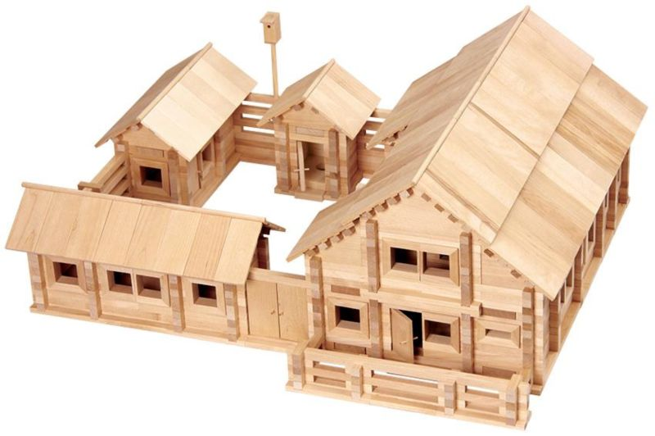
REQUEST
to finance a humanitarian project
Institutions "Kirovsky District Center for Social Services"

1. | Name of the project | «Eco-zone for people with disabilities»
2. | Name of company | institution "Kirovsky district center of social services"
3. | The physical and legal address of the organization, phone, fax, e-mail | Mogilev region, the city of Kirovsk, Kirov street, 63, 80223779533, RCSON06@mail.ru
4. | Organization Information | In 2000, the institution “Kirovsky District Center for Social Services for the Population” was established to improve community outreach.  The main activities of the organization:  - identification and differentiated (by category) registration of citizens in difficult situations, determination of the forms of social services they need, types of social services, etc.  The institution employs 92 employees (staffing 96 people), including heads of structural divisions 10 people, specialists 23, workers 15, social workers 44
5. | Head of the organization | Director of the center Merzhiy Olga Nikolaevna, 80223777302
6. | Project manager | Natalya Finevich, Head of the Day Care Unit for Disabled and Senior Citizens, 80223779533; +375291703685, kirovsk.c@mintrud.by
7. | Previous assistance received from other foreign sources | -
8. | Amount Required | 27500USD
9. | Co-financing | 18600USD
10. | Project term | 2 year
11. | Objective of the project | assistance to people with disabilities in preparing for an independent life, adaptation to the conditions of life and work, their environmental education.
12. | Project objectives | creation and arrangement of an eco-zone (according to TCP 45-3.02-318-2018 (33020)) to adapt to the independent life of people with disabilities on the territory of the Staykovsky rural executive committee in order to reduce CO2 emissions;  the development of people with disabilities independence in self-service and the use of household items;  environmental education and raising the awareness of persons with disabilities on measures to improve the ecological state of the area;  reducing the level of social isolation, increasing the self-esteem of people with disabilities.
13. | Detailed description of the project activities in accordance with the tasks | 1. Creation and arrangement of an eco-zone (according to TCP 45-3.02-318-2018 (33020)) for adaptation to independent life of people with disabilities on the territory of the Staykovsky rural executive committee, in order to reduce CO2 emissions.  1.1. purchase and installation of an eco-house;  1.1.1. purchase of furniture;  1.1.2. purchase of bedding, home textiles;  1.2. purchase and installation of an eco-kitchen;  1.2.1. purchase of furniture;  1.2.2. Purchase of utensils;  1.2.3. purchase of household appliances (refrigerator, blender, washing machine, etc.);  1.3. purchase and installation of a shower cabin;  1.4. purchase and installation of a dry closet for disabled people.  2. Development of people with disabilities independence in self-service and use of household items:  2.1. settlement and arrangement of everyday life on the basis of the project;  2.2. Conducting classes on teaching self-service skills (shopping, budget planning, cooking, cleaning, washing, body care, etc.).  3. Environmental education and awareness raising for persons with disabilities on measures to improve the ecological state of the area:  3.1. creation of a laptop (thematic folder) "Ecology";  3.2. conducting a brainstorming session "Methods of air protection", a collective game "I am able to see problems";  3.3. conducting a quest game "Ecological trail" using health-saving technologies (in conclusion, the test "Human health and the environment").  4. Reducing the level of social isolation, increasing the self-esteem of people with disabilities:  4.1. holding a regional event "EcoDay without Barriers".
14. | Project Justification | The implementation of the project "Eco-zone for people with disabilities" will be a good start for preparing people with disabilities for an independent life. It is expected that this will be expressed in the creation of an eco-center, which will be a coordinating link aimed at creating conditions for social adaptation and integration into society of people with special needs and their families in the Kirovsky region.  A wide coverage of the entire spectrum of interests of people with disabilities, the development of common guidelines, the emergence of the integrity of an inclusive and equal society will help not only to organize the sustainable development of socio-cultural rehabilitation of people with disabilities, but also to offer the use of the experience gained to other areas.  The foundation laid and the mechanisms implemented will ensure the further development of the project in the form of realizing the basic rights of people with disabilities - living in society.
15. | Activities after the end of the project | As a result of the implementation of the "Eco-zone for people with disabilities" project, eco-zones (house, shower, toilet, kitchen) were created and equipped, where 20 people with disabilities will be trained in self-service skills.  A number of activities were carried out to improve the awareness of persons with disabilities about measures to improve the ecological state of the district, in which 20 people with disabilities took part.  A regional event "EcoDay without Barriers" was held for people with disabilities, in order to reduce social isolation, in which 48 disabled people living in Klichevsky, Bobruisk, Osipovichsky, Kirovsky, Glusky districts of the Mogilev region participated.  During the implementation of the project, the emission of toxic substances in the form of exhaust gases from cars into the environment will be reduced, because people with disabilities will study and live on the territory of the Staykovsky rural executive committee for 30 days and they will not be transported by car.  The implemented project trained 20 people with disabilities in self-service skills, behavior in everyday life and in public places, self-control, communication skills and other forms of life.
16. | Project budget | 46100 USD

